**CSE102L Computer Programming Lab**

**LAB # 8**



**2020**

**Submitted to:**

**Engr. Abdullah Hamid**

**Submitted by:**

**TAYYABA**

**Registration No :**

**19PWCSE1854**

**Semester: 2nd**

**Class Section:** **C**

“On my honor, as student of University of Engineering and Technology,

I have neither given nor received unauthorized assistance on this

academic work.”

JUly 24 , 2020

**Department of Computer Systems Engineering**

**University of Engineering and Technology, Peshawar**

**Pointers and References**

# Task 1:

# Title:

Write a C++ program where you take two values in two variables from user, add the values of the two variables and put it into a third variable using a pointer you must use only one pointer.

# Code:

#include<iostream>

using namespace std;

int main()

{

int val1, val2, sum = 0, *ptr = &sum;

cout<<"Enter first value: ";

cin>>val1;

cout<<"Enter second value: ";

cin>>val2;

sum = val1 + val2;

cout<<"Sum of "<<val1<<" and "<<val2<<" is "<<*ptr;

return 0;

}

# Output:

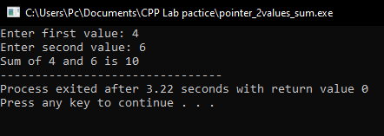

# Task 2:

# Title:

Write a C++ program where you take two values from user in two variables, swaps the values of the variables using references (&).

# Code:

#include<iostream> #include<conio.h>

void swap(int& a, int& b); using namespace std;

int main() {

int val1, val2; cout<<"Enter first value: "; cin>>val1;

cout<<"Enter second value: "; cin>>val2;

cout<<"Values Before swaping:\nval1 = "<<val1<<", val2 = "<<val2<<endl; swap(val1, val2);

cout<<"After swaping\nval1 = "<<val1<<" val2 = "<<val2;

return 0;

}

void swap(int& a, int& b) {

a += b;

b = a - b;

a = a - b

}

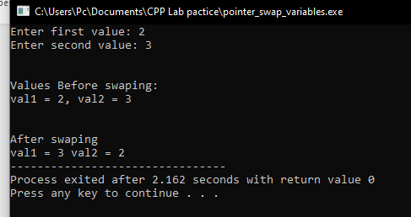

# Task 3:

# Title:

Write a C++ program where you take a value in a variable from user increment that value by 5 using a pointer in a for loop and display its play using pointer.

# Code:

#include<iostream>

using namespace std;

int main()

{

int var, *ptr = &var;

cout<<"Enter a value = ";

cin>>var;

for(int i = 0; i < 5; i++)

{

(*ptr)++;

}

cout<<"\n\nThe incremented Value by 5 is = "<<*ptr;

return 0;

}

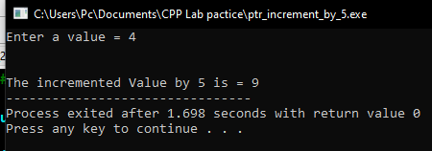

# Task 4:

# Title:

Write a C++ program where you take your first name from user in a string variable using pointer edit that string to your last name and then display that string variable (your last name must be hard coded in a separate string variable).

# Code:

#include<iostream>

#include<string.h>

using namespace std;

int main()

{

string firstName,

*ptr = &firstName,

secondName = " Fakhar";

cout<<"Enter your First Name: ";

cin>>firstName;

cout<<"\n\nYour Name before editing = "<<firstName;

*ptr = firstName + secondName;

cout<<"\n\n\nYour Name after editing = "<<firstName;

return 0; }

# Output:

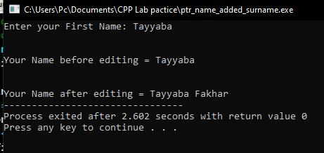

# Task 5:

# Title:

Display 1 to n numbers using pointer, user must enter the n.

# Code:

#include<iostream>

using namespace std;

int main()

{

int a, b = 1, *ptr = &b;

cout<<"Enter a number: ";

cin>>a;

cout<<"\n\nThe list from 1 to "<<a<<" is = ";

while(*ptr <= a)

{

cout<<*ptr<<" ";

(*ptr)++;

}

return 0;

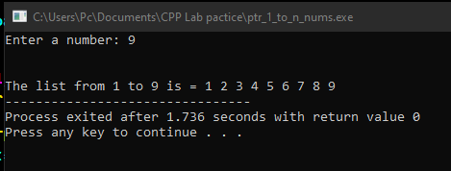

# Task 6:

# Title:

Add even numbers from 1 to n using pointers user must enter n.

# Code:

#include<iostream> using namespace std; int main() {

int a, b = 2, *ptr = &b, sum = 0, *ptrsum = &sum; cout<<"Enter a number: ";

cin>>a; while(*ptr <= a) {

*ptrsum += *ptr;

*ptr += 2;

}

cout<<"The sum of even numbers from 1 to "<<a<<" = "<< *ptrsum<<endl;

return 0;

}

